 |  |  |  | 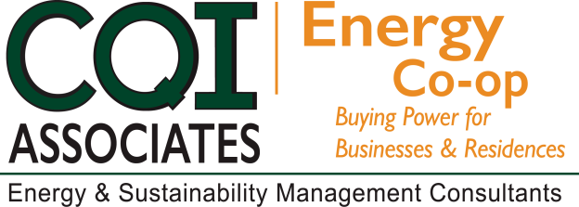
2018 FALL CAMPAIGN

Dear Chamber Member,
The Chamber of Commerce has partnered with energy experts, CQI Associates, to offer you the services of the Chamber Energy Purchasing Cooperative Program. As part of an ongoing effort to provide value to our members, we are happy to announce the Fall 2018 enrollment campaign is underway.
BENEFITS  Increased Purchasing Power in procuring competitive electric and natural gas rates through aggregation buying pools.  Budget Stability by offering Fixed Rate energy supply costs.  Year-round Customer Support through CQI Associates.  NO FEE to join the Co-op and one application covers ALL of your electricity and natural gas accounts for ALL locations.  WEBINAR SCHEDULE  September 11, 2018 - 1:00 p.m.  September 18, 2018 - 11:00 a.m.  September 25, 2018 - 1:00 p.m.  To participate, please select date above (Ctrl + Click) and continue to registration page.  Other Cost Saving Services are Available |  |  | NO HASSLE PROCESS  - Obtain a Letter of Authorization from  your Chamber website or contact CQI Associates.  - Complete and Sign the Letter of Authorization.  - Provide a recent copy of your Utility bill(s), all pages, for all accounts you are enrolling and a copy of your current contract, if applicable.  Scan and email full copies of all documents to joe@cqiassociates.com or fax to 410-630-5911  Mail the originals to:  Salisbury Area Chamber of Commerce  P.O. Box 510  144 East Main Street  Salisbury, MD 21803
The application deadline for the Chamber of
Commerce Energy Purchasing Cooperative
program is Friday, September 28, 2018.
Questions? Please contact:
Joe Tabeling - joe@cqiassociates.com (443)472-3870
Greg Pasha – gregpasha@cqiassociates.com (443)745-8487

"Serving Chamber Members as the Trusted Energy Advisor since 2004"

