Salisbury Area Chamber of Commerce First Annual Golf Tournament Information

Date: Friday, September 29, 2017

Place: Green Hill Country Club
5471 Whitehaven Rd,
Quantico, MD 21856

Time: | 8:00 a.m. | Check Inn & Breakfast
 | 9:00 a.m.  2:00 p.m. | Shotgun Start  Awards Lunch
Format:

Prizes: ● Prizes awarded to the top three teams for low net and gross score (one prize per team).
- 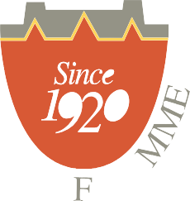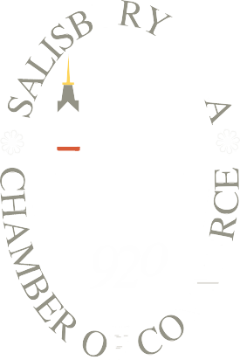Official USGA handicaps must be provided t compete for low-net prizes.
- Hole-in-One prize package
- Closest to the pin prizes on all par threes.
- Longest Drive

